**Excel Assignment – 10**

**1. See the below picture and create the exact table with exact formatting. Font – ‘Times New Roman’ Size – 14, Color of first line Orange.**

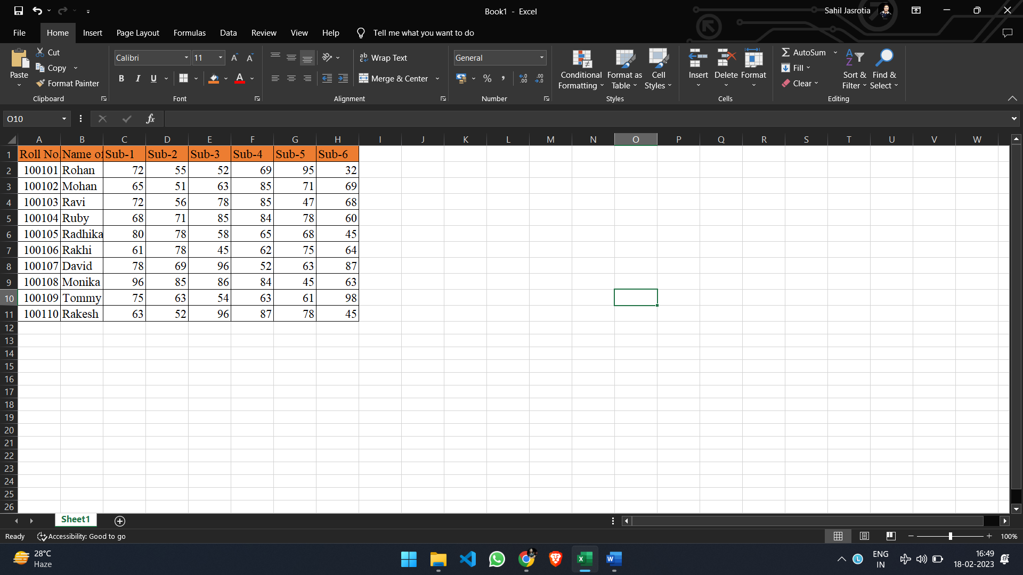

**2. From the above table use Sum Formula and find the total for each student.**

Formula =SUM(C2:H2)

**3. Calculate Average for each student in the next row. Use Formulas.**

Formula =AVERAGE(C2:H2)

**4. Calculate Rank for each student. Use Formulas.**

Formula =RANK.EQ(I2,$I$2:$I$11,0)

**5. Calculate Percentage for each student. Use Formulas. Round off the**

**decimals up to 2 points.**

Formula = =I2/600*100

Result:

